# Unity Store Example

## Invoice

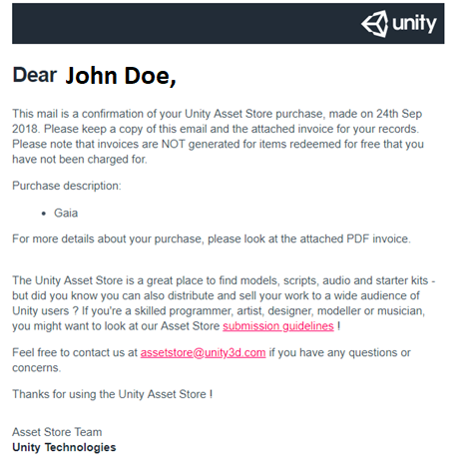

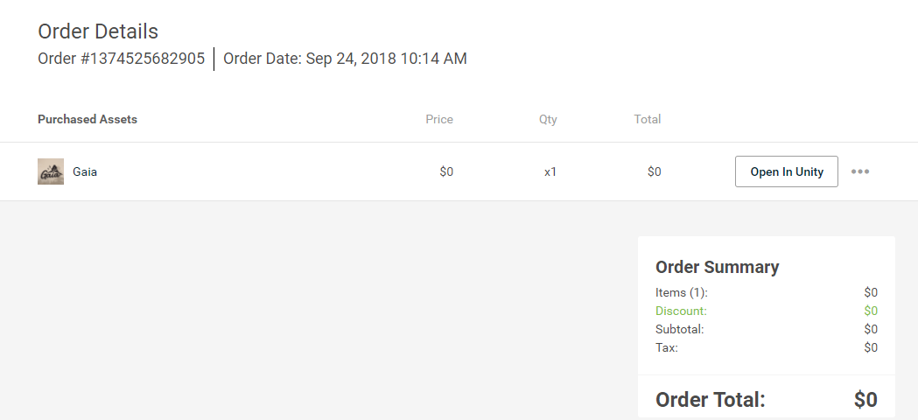

### Attributes (0NF)

CustomerID, CustomerName, CustomerEmail, OrderNumber, Order Date, {AssetID, AssetName, Price, ItemQuantity, ItemTotal}, OrderItemAmount, Discount, Subtotal, Tax, OrderTotal

### 1NF

OrderNumber, CustomerID, CustomerName, CustomerEmail, Order Date, OrderItemAmount, Discount, Subtotal, Tax, OrderTotal

OrderNumber (fk), AssetID, AssetName, Price, ItemQuantity, ItemTotal

### 2NF

OrderNumber, CustomerID, CustomerName, CustomerEmail, Order Date, OrderItemAmount, Discount, Subtotal, Tax, OrderTotal

OrderNumber (fk), AssetID (fk), AssetHistoricalPrice, ItemQuantity, ItemTotal

AssetID, AssetName, AssetCurrentPrice

*decided to store historical price and current price

### 3NF

OrderNumber, CustomerID (fk), Order Date, OrderItemAmount, Discount, Subtotal, Tax, OrderTotal

CustomerID, CustomerName, CustomerEmail

OrderNumber (fk), AssetID (fk), AssetHistoricalPrice, ItemQuantity, ItemTotal

AssetID, AssetName, AssetCurrentPrice

### ERD

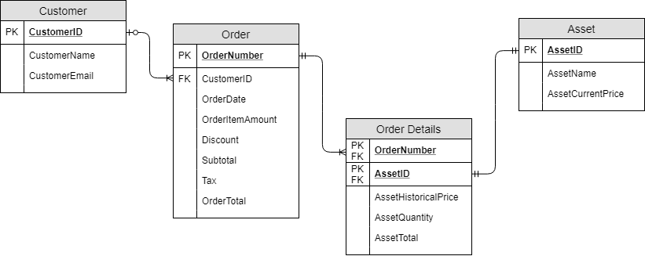

## Product View

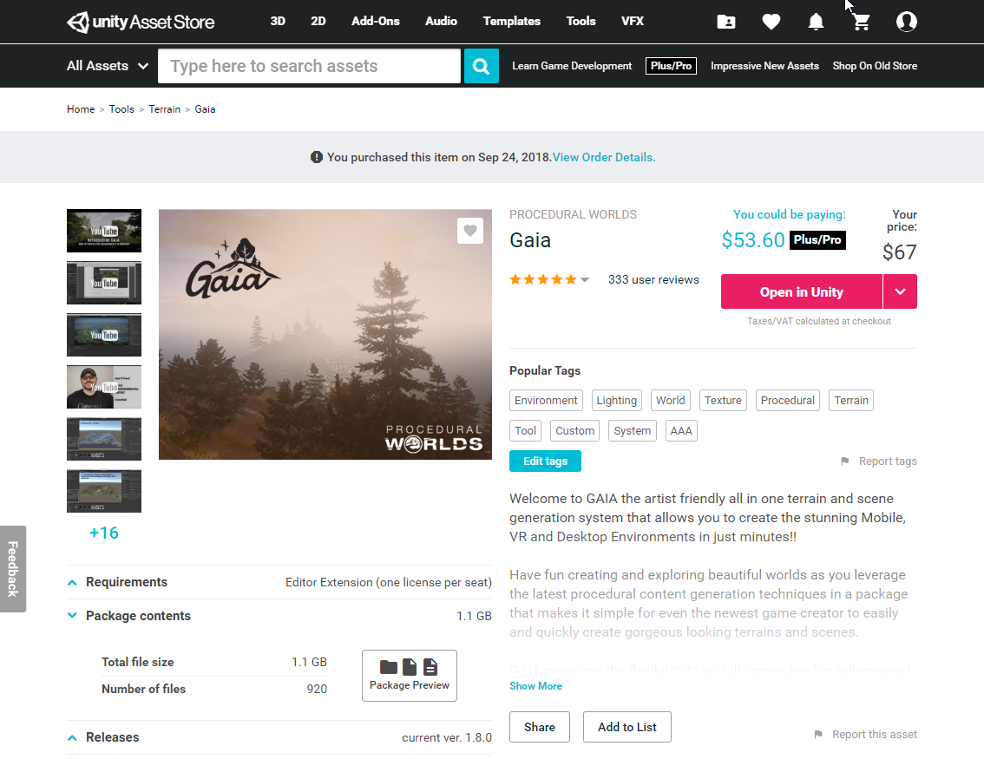

### Attributes (0NF)

*license type will be asset or editor extension

**Assume users don’t create tags, just pick from a list if they “Edit tags”

### 1NF

### 2NF

### 3NF

### ERD

## Publisher Products View

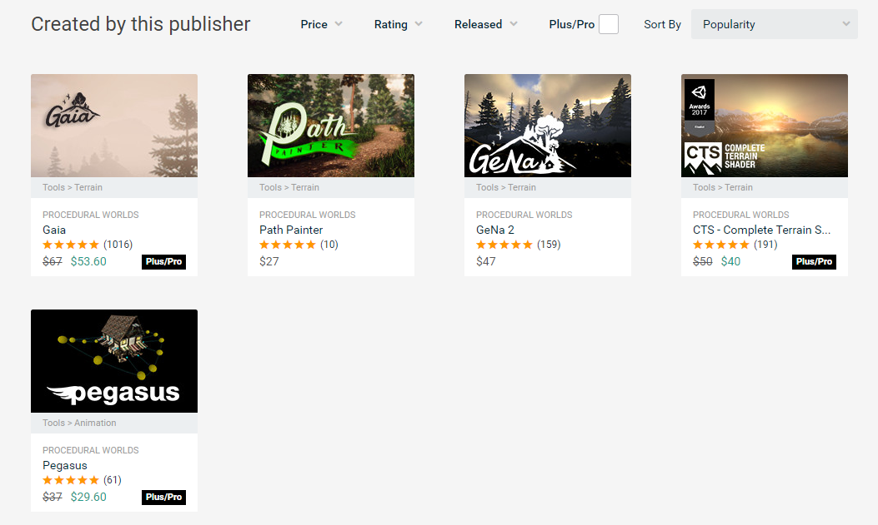

### Attributes (0NF)

* Type will be Plus/Pro or personal

### 1NF

### 2NF

### 3NF

### ERD

## User Profile View

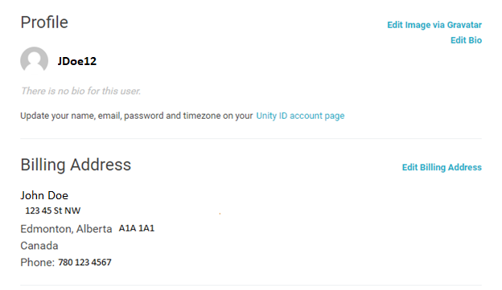

### Attributes (0NF)

*Profile name is based off email

### 1NF

### 2NF

### 3NF

### ERD

## Merged ERD